Operating Systems Lab Experiment 01: Basic Linux Commands

1. **ls – It lists the contents of the directory.**

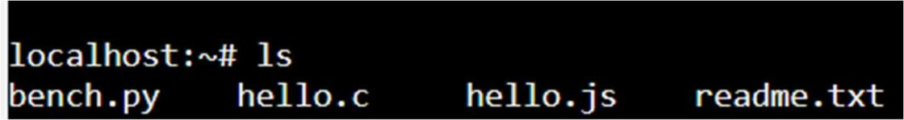

1. **cat – It displays the contents of the files**

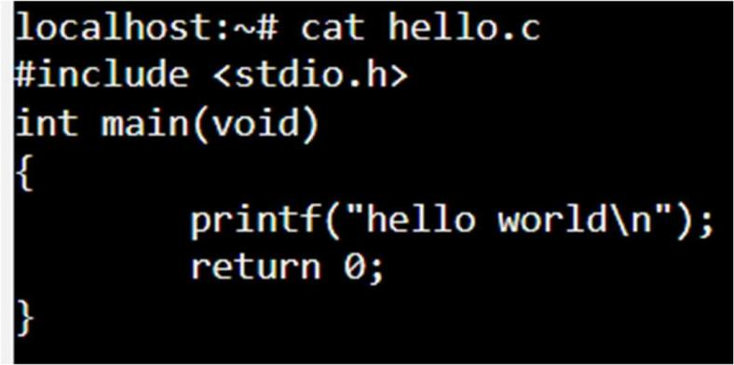

1. **pwd – It prints the current working directory**

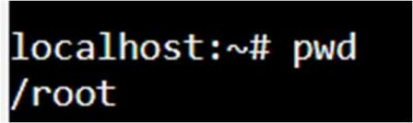

1. **whoami – It displays the current user name**

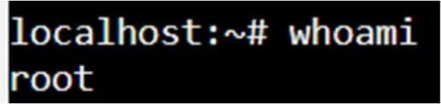

1. **clear – It clears the terminal screen.**

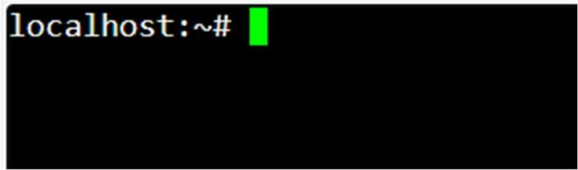

1. **mkdir – It creates a new directory**

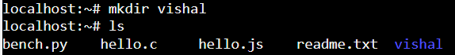

1. **cd – It changes the current working directory**

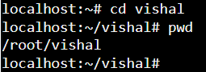

**C**

1. **cd .. – It moves back to the parent directory.**

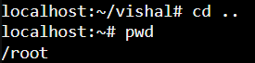

1. **rmdir – It deletes the directory.**

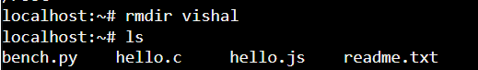

1. **cat > helllo.txt – It allows us to create a file named hello.txt and allows to write content in it. Press Ctrl + D to save and exit.**

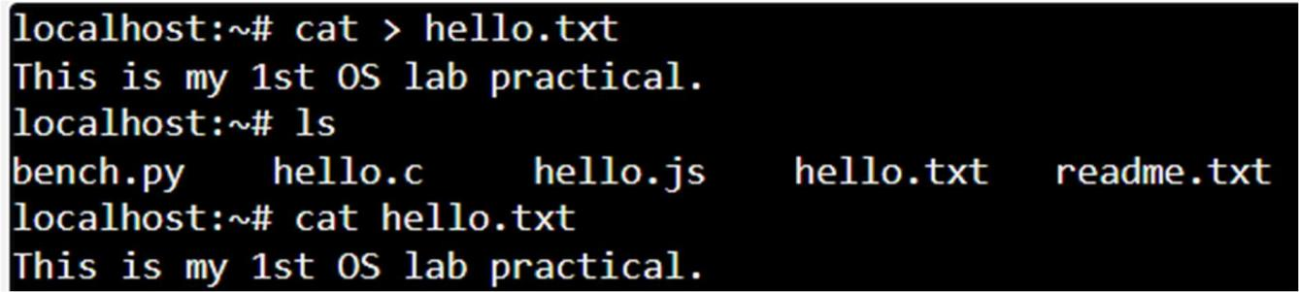

1. **cat >> hello.txt – It appends the content to the hello.txt file.**

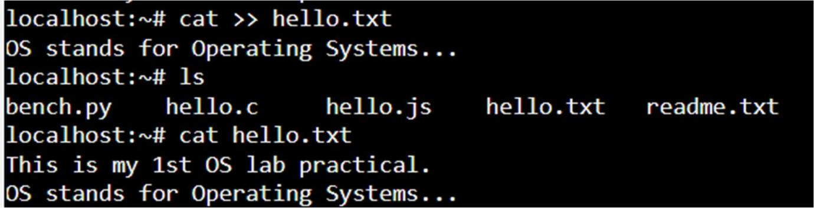

1. **cp hello.txt bye.txt – It copies hello.txt file to a new file named bye.txt. Here, hello.txt acts as source file and bye.txt as a destination file.**

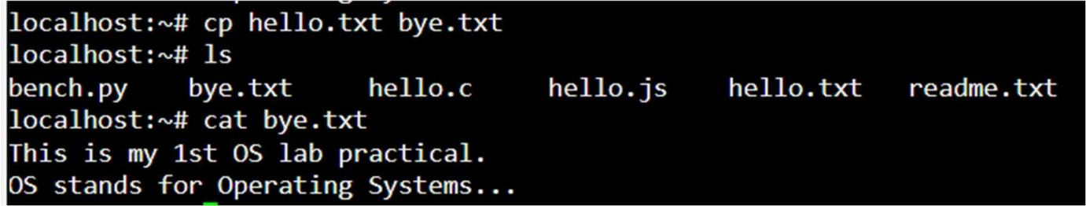

1. **mv bye.txt file.txt – It renames or moves bye.txt file to file.txt file. Here, bye.txt is source file and file.txt is destination file.**

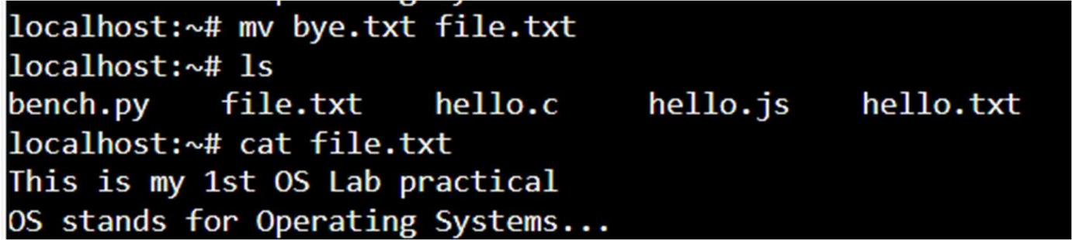

1. **rm file.txt – It deletes the file ‘file.txt’.**

